Project Design Phase-II

Data Flow Diagram & User Stories

|  |  |
| --- | --- |
| Date | 27 October 2022 |
| Team ID | PNT2022TMID31571 |
| Project Name | Project -Smart Fashion Recommender Application |
| Maximum Marks | 4 Marks |

# Data Flow Diagrams:

A Data Flow Diagram (DFD) is a traditional visual representation of the information flows within a system. A neat and clear DFD can depict the right amount of the system requirement graphically. It shows how data enters and leaves the system, what changes the information, and where data is stored.

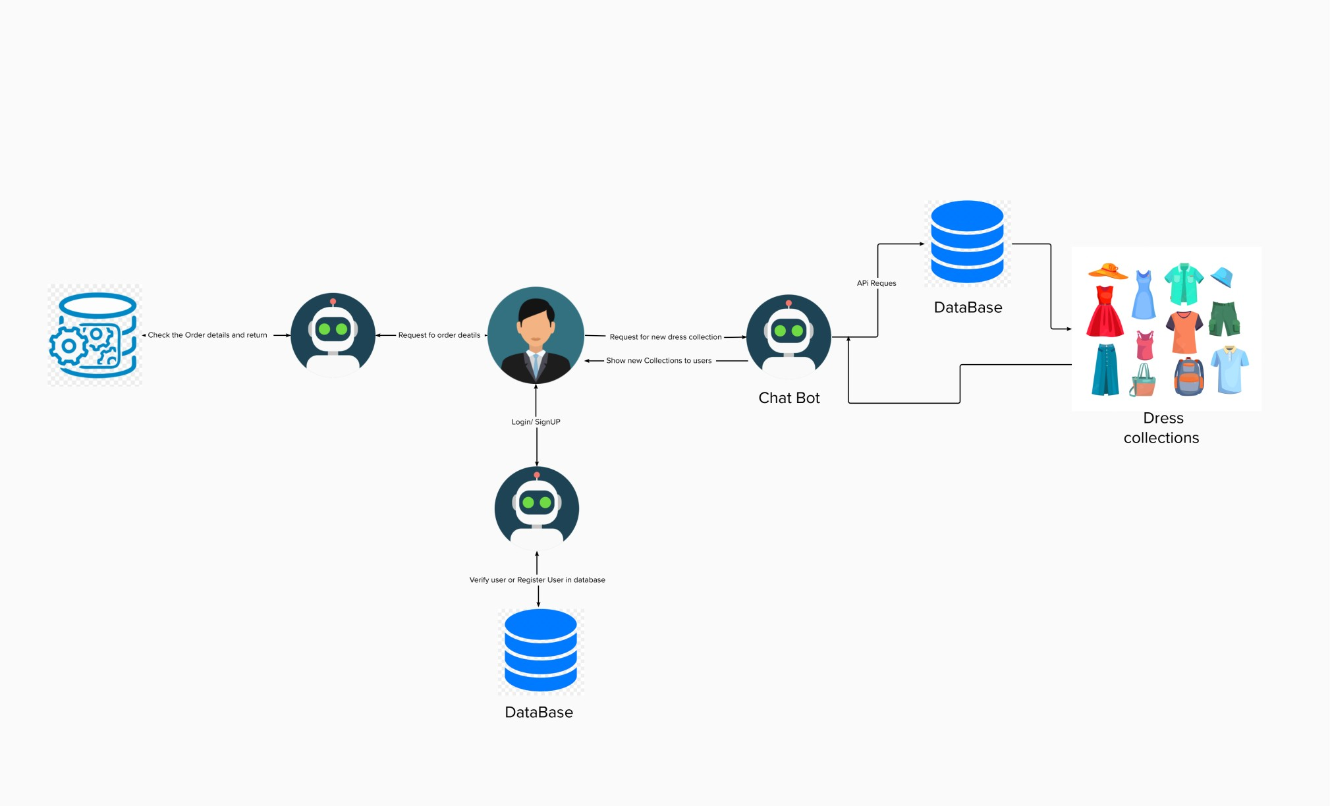

# User Stories

Use the below template to list all the user stories for the product.

|  |  |  |  |  |  |  |
| --- | --- | --- | --- | --- | --- | --- |
| **User Type** | **Functional**  **Requirement (Epic)** | **User Story Number** | **User Story / Task** | **Acceptance criteria** | **Priority** | **Release** |
| Customer (Mobile user) | Registration | USN-1 | As a user, I can register for the application by entering my email, password, and confirming my password. | I can access my account / dashboard | High | Sprint-1 |
|  |  | USN-2 | As a user, I will receive confirmation email once I have registered for the application | I can receive confirmation email & click confirm | High | Sprint-1 |
|  |  | USN-3 | As a user, I can register for the application through Facebook | I can register & access the dashboard with Facebook Login | Low | Sprint-2 |
|  |  | USN-4 | As a user, I can register for the application through Gmail |  | Medium | Sprint-1 |
|  | Login | USN-5 | As a user, I can log into the application by entering email & password | I can access my data by login | High | Sprint-1 |
|  | Dashboard | USN-6 | As a user , I can view the dashboard and by products |  | High | Sprit -2 |
| Customer (Web user) | Registration / Login | USN-7 | As a user, I can register for the application by entering my email, password, and confirming my password. | I can access my account / dashboard |  | Sprint -1 |
| Customer Care Executive | Contact with Customers | USN-8 | As a Customer customers care executive, I solve the customer Requirements and feedback | I can receive calls from customers | High | Sprint-1 |
| Administrator | Check stock and Price , orders | USN_9 | As a Administrator , I can Check the database And stock details and buying and selling prices | I am the administrator of the company | High | Sprint -2 |